HANOI UNIVERSITY
FACULTY OF INFORMATION TECHNOLOGY

------------------------------o0o------------------------------

Assignment title: ATI – Reports
GROUP MEMBERS:
1.2301140081 – Nguyễn Thế Quang
2. 2301140092 - Đỗ Thị Hoài Thương
3. 2301140037 – Vũ Việt Hoàng
Course title: ATI
Submission date: 19/12/2025

2025-2026
Table of Contents

1. INTRODUCTION 4
1.1 Problem Statement 4
1.2 Dataset and Challenges 4
2. METHODOLOGY 4
2.1. Data Preparation 4
2.2. Handling Class Imbalance 4
2.3. Model Architecture 5
3. EXPERIMENTAL RESULTS AND ANALYSIS 5
3.1. Training History & Learning Curves 5
3.2. Confusion Matrix Analysis 5
4. CONCLUSION 6

Abstract

This paper describes the creation and testing of a Convolutional Neural Network (CNN) used to categorize retinal fundus pictures into eight unique disease categories. The dataset consists of 9,868 pictures, with a large class imbalance. To overcome this issue, the study used optimization approaches such data augmentation and class-weighting algorithms. Experimental findings on the test set show an overall accuracy of 54.78%. A thorough examination of the Confusion Matrix indicates that, while the model performs well on different classes (for example, Class 6), it has a large bias toward the majority class (Class 0), resulting in poor performance on minority classes (for example, Class 7). The research continues with recommendations for future improvements based on Transfer Learning and enhanced sampling approaches.

1. INTRODUCTION

1.1 Problem Statement
Retinal diseases are the primary cause of avoidable blindness worldwide. These disorders must be diagnosed by studying fundus pictures, which contain complicated networks of blood vessels and minor abnormalities. This intricacy, along with human weariness, causes a bottleneck in diagnosis. This research tries to automate the procedure by using a CNN to analyze visual complexity and reliably categorize disorders into eight categories (normal, diabetes, glaucoma, cataract, AMD, hypertension, myopia, and other).

1.2 Dataset and Challenges
The database consists of 9,868 retinal fundus pictures. During inspection, two serious concerns were identified:
1. Missing Metadata: The patient demographic information was incomplete. To preserve data integrity, metadata was detached, and the model was trained only on visual pathology.
2. Severe Class Imbalance: The distribution is significantly skewed, with the 'Normal' class dominating the dataset. Training directly on this distribution would result in a skewed model that fails to recognize uncommon but serious illnesses.

2. METHODOLOGY

2.1. Data Preparation
To provide rigorous evaluation and robust training, the following pipeline has been implemented:
Image Resizing: The original photos (512x512) were reduced to 254x254 pixels to accommodate hardware limits and allow for quicker iteration.
Stratified Splitting: Rather than random splitting, the data was divided into three sets: training (75%), validation (12.5%), and test (12.5%). This ensures that the distribution of uncommon illnesses is the same across all subgroups.

2.2. Handling Class Imbalance
The 'Normal' class's dominance presented a significant issue. Two particular optimizations were implemented:
Weighted Random Sampler: Rather of changing the loss function, a weighted random sampler was used. The weights allocated to photos were inversely proportionate to their class frequency. This guarantees that each training batch is statistically balanced, requiring the model to learn minority classes.
Data Augmentation: Real-time transformations (horizontal flips, rotations, and scaling) were used to keep the model from storing certain pixel layouts.

2.3. Model Architecture
A bespoke CNN was created from scratch, with around 8.5 million parameters. Convolutional Backbone: Four consecutive blocks with increasing filter levels(16 to 32 to 64 to 128). Each block uses Batch Normalization for stability and Max Pooling for dimension reduction. Classifier Head: The feature maps are flattened into a vector, passed through a Dropout layer (0.25) to reduce overfitting, and then processed by fully connected layers to provide the 8-class probabilities.

3. EXPERIMENTAL RESULTS AND ANALYSIS

3.1. Training History & Learning Curves
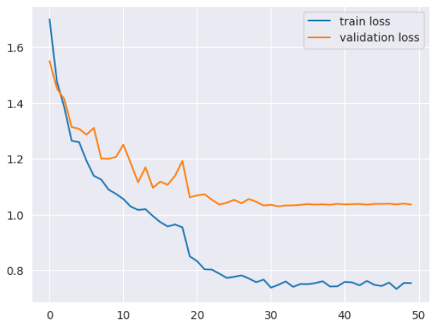
The Learning Curve (Figure 1) shows that both training and validation losses rapidly reduce and stabilize at epoch 30. The Validation Loss does not diverge, showing that the Dropout and Augmentation techniques effectively avoided catastrophic overfitting. However, the accuracy declines at around 55%, indicating the model has reached its capacity limit with the current architecture/resolution configuration.0.55 (55%),
The model has a test accuracy of 54.78%.
In an 8-class unbalanced dataset, a random guess produces 12.5%. Our model outperforms random chance by 4.4x, demonstrating that the Weighted Samplereffectively trained the model to discriminate characteristics rather than collapse to the majority class.

3.2. Confusion Matrix Analysis
The Confusion Matrix identifies three main findings:
- Success in Class 6 (Myopia): High Precision (0.84). The model effectively learns macroscopic characteristics (tessellated fundus) that are distinguishable even at 254x254 resolution.
- Failure - Class 1 (Diabetes): Significant misidentification as "Normal" (Class 0).
Root Cause: Microaneurysms are the defining feature of early diabetes. Downscaling to 254 pixels dulled these fine details, making sick eyes appear healthy to the model.
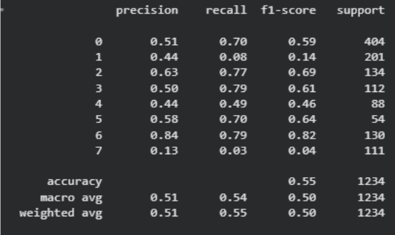
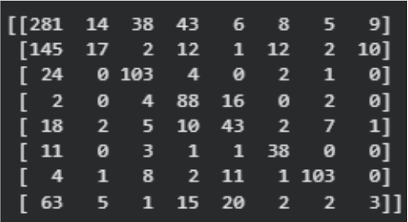
- Failure - Class 7 (Other): Recall ~0.03. This "garbage class" consists of diverse uncommon illnesses that lack a consistent visual pattern for the model to learn.

4. CONCLUSION
The model architecture and Weighted Sampler successfully managed class imbalance, outperforming random chance 4.4 times. However, the 254x254 resolution is the main constraint.
Future improvements:
1.High Resolution Training: To catch microaneurysms, use 512x512 pictures.
2.Transfer Learning: Use ResNet50 or EfficientNet to improve feature extraction.

